**CERTIFICATE OF DEPOSIT**

* We deposit a lump sum into an account for a fixed period of time, during which the account holder is paid interest by the bank, generally daily or monthly. Once a CD reaches its maturity date, the account holder has the option to either withdraw their original deposit plus the interest earned or renew the CD for an additional term.
* There are three main factors to understanding how a CD works:

1. Deposit amount: The dollar amount that is put into the account
2. Term: The period of time until the account matures
3. Interest rate: The annual percentage yield the bank pays the account holder in interest

* Certificate of deposit in India can be issued for a minimum deposit of Rs. 1 lakh or in subsequent multiples of it.
* CDs are considered one of the safest investment options because they are typically insured by the government up to a certain limit (e.g., $250,000 per depositor per bank in the United States by the FDIC).
* In aggregate, certificate of deposit (CD) balances at US banks climbed to $2.870 trillion in the fourth quarter of 2023, up 6.9% from the previous quarter and 68.0% year over year, S&P Global Market Intelligence data shows. While the CD balances continued to rise, the rate of growth has slowed since increasing 24.8% in the first quarter of 2023.
* CD rates have been relatively high due to the Federal Reserve's rate hikes in 2022 and 2023. The average rate for a five-year CD is around 1.43% annual percentage yield (APY), which is significantly higher than the national average rate for regular savings accounts at 0.45% APY​

|  |  |  |  |  |
| --- | --- | --- | --- | --- |
| Year | CDs/ total deposits (%) | Brokered deposits/ total deposits (%) | FHLB advances / total liabilities (%) | Total loans and leases/ total deposits (%) |
| 2016 | 12.0 | 6.0 | 4.0 | 72 |
| 2017 | 12.5 | 6.72 | 4.0 | 72.5 |
| 2018 | 13.0 | 7.25 | 3.46 | 73 |
| 2019 | 12.5 | 7.5 | 3.0 | 70 |
| 2020 | 9.0 | 6.5 | 2.36 | 58 |
| 2021 | 8.0 | 6.25 | 2.5 | 60 |
| 2022 | 10.0 | 7.33 | 2.5 | 63 |
| 2023 | 15.0 | 8.36 | 3.0 | 65 |

**MONEY MARKET ACCOUNTS**

* A [money market account](https://www.latimes.com/compare-deals/banking/money-market/best-money-market-accounts) is a deposit account offering higher rates than a traditional savings account. Once We make Your initial deposit, we can add money at any time, making it easier to grow Your balance. We also earn interest on Your deposits.
* Working: Money market accounts work like other types of bank accounts. We can deposit cash, checks, transfer funds from checking or take advantage of other deposit methods. We also get a debit card or check-writing privileges, allowing We to access Your funds quickly. Note that some money market accounts have withdrawal limits. If We exceed the limit, we may have to pay a fee. Generally, money market accounts are ideal for individuals with short-term savings goals.
* As of June 2024, total money market fund assets stood at approximately $6.1 trillion. This represented a slight decrease of $22.32 billion over a six-day period, mainly driven by a reduction in government funds and prime funds​.
* Money Market Accounts are insured by the FDIC (Federal Deposit Insurance Corporation) for banks and the NCUA (National Credit Union Administration) for credit unions, up to $250,000 per depositor, per institution, providing a high level of safety for depositors.
* Currently, the average APY for standard money market accounts is 0.66%, according to the [**FDIC**](https://www.fdic.gov/resources/bankers/national-rates/index.html). Several banks offer high-yield money market accounts with APYs of 4% or higher including [**U.S. Bank**](https://www.latimes.com/compare-deals/banking/money-market/us-bank-money-market-accounts), Quontic and EverBank.
* **Truth in Savings Act**: This act requires banks and credit unions to provide clear and accurate information about the terms and conditions of MMAs, including the annual percentage yield (APY), fees, and other important details.
* The SEC regulates money market funds under Rule 2a-7 of the Investment Company Act of 1940. These regulations are designed to ensure stability and liquidity, including requirements for diversification, credit quality, and maturity of assets.

|  |  |
| --- | --- |
| Month- Year | National Average Money Market Rate (%) |
| Apr 2022 | 0.10 |
| July 2022 | 0.15 |
| Oct 2022 | 0.30 |
| Jan 2023 | 0.45 |
| Apr 2023 | 0.52 |
| Jul 2023 | 0.53 |
| Oct 2023 | 0.54 |
| Jan 2024 | 0.57 |

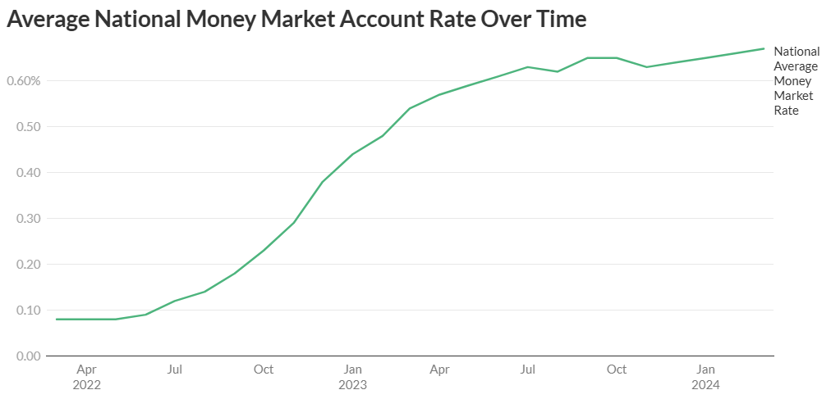

|  |  |
| --- | --- |
| Account Type | Average Interest Rate |
| Checking Account | 0.01% - 0.05% |
| Savings Account | 0.30% - 0.60% |
| Certificate of Deposit (1-year) | 1.25% - 1.75% |
| Money Market Account | 0.40% - 0.70% |

**INDIVIDUAL RETIREMENT ACCOUNTS (IRAs)**

* An IRA is a retirement savings account that provides We with tax-free investment growth and a range of other tax advantages. Anyone who earns income—and even certain people who don’t—can contribute money to an IRA.
* If We invested $5,000 a year for 40 years in an IRA with a 7% average annual return, we’d end up with just over $1 million by the time We hit retirement.
* if We don’t have a workplace retirement plan, an IRA is one of the best options
* Forty-five percent of IRA assets, or $6.2 trillion, your invested in mutual funds. The most common type of IRA is the traditional IRA, which was created by the Employee Retirement Income Security Act of 1974 (ERISA)
* The IRS has increased the annual contribution limits for IRAs starting in 2024. The limit for contributions has risen from $6,500 to $7,000, while individuals aged 50 and older can make catch-up contributions, increasing their total contribution to $8,000 annually. These changes are part of the SECURE Act 2.0 adjustments.
* IRAs Are the Largest Share of US Retirement Assets. The total retirement assets amount to $39.3 trillion.

|  |  |
| --- | --- |
| Category | Percentage |
| IRAs | 35% |
| Defined contribution plans | 28% |
| State and Local govt. defined benefit plans | 15% |
| Federal defined benefit Plans | 6% |
| Private Sector defined benefit plans | 10% |
| Annuities | 6% |

* IRAs are owned by individuals of all ages, but ownership is greatest among older groups of working-age individuals.

|  |  |
| --- | --- |
| Age Group | % of US Households Owning IRAs |
| Wenger than 35 | 31 |
| 35 to 44 | 36 |
| 45 to 54 | 39 |
| 55 to 64 | 43 |
| 65 or older | 36 |